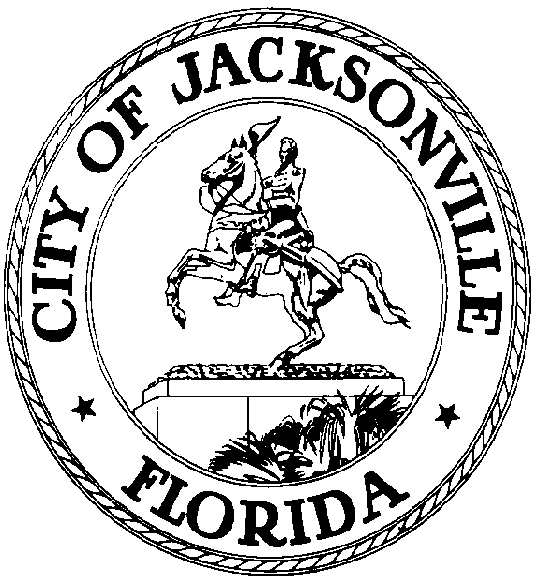

GARRETT L. DENNIS
Council Member District 9
E-Mail: GarrettD@coj.net

OFFICE OF THE CITY COUNCIL
117 West Duval Street City Hall, Suite 425
Jacksonville, Florida 32202
Office (904) 255-5209
Fax (904) 255-5230

MEDIA RELEASE

FOR IMMEDIATE RELEASE – May 26, 2020
Contact: Taryn Roberts (904) 255 -5161, TGRoberts@coj.net

COVID-19 RELIEF BILL INTRODUCED BY COUNCIL MEMBER GARRETT DENNIS PASSES UNANIMOUSLY

JACKSONVILLE, Fla. – Tonight the Jacksonville City Council unanimously passed bill 2020-0243 introduced by Councilman Garrett Dennis.

“This bill appropriates $5 million of CARES Act, and allows us to help 5,000 additional families who have been drastically affected by the COVID-19 pandemic. We have a responsibility to offer assistance to those who have had a loss of employment, or a significant reduction in hours by no fault of their own,” Dennis said.

